**DAILY ONLINE ACTIVITIES SUMMARY**

|  |  |  |  |  |  |  |  |
| --- | --- | --- | --- | --- | --- | --- | --- |
| **Date:** | **08/07/2020** | | | | **Name:** | **Syed Rabeya Aamir** | |
| **Sem & Sec** | **8th B** | | | | **USN:** | **4AL16CS112** | |
| Online Test Summary | | | | | | | |
| **Subject** | | **__** | | | | | |
| **Max. Marks** | | **__** | | **Score** | | **---** | |
| Certification Course Summary | | | | | | | |
| **Course** | **INTRODUCTION TO CYBER SECURITY.** | | | | | | |
| **Certificate Provider** | | | **Great Learning** | **Duration** | | | **5.5 hrs** |
| Coding Challenges | | | | | | | |
| **Problem Statement:**  **1)**  Python code to demonstrate clearing a list using *= 0 method. | | | | | | | |
| **Status: Solved** | | | | | | | |
| **Uploaded the report in Github** | | | | **YES** | | | |
| **If yes Repository name** | | | | **rabeya** | | | |
| **Uploaded the report in slack** | | | | **YES** | | | |

**Certification Course Details:**

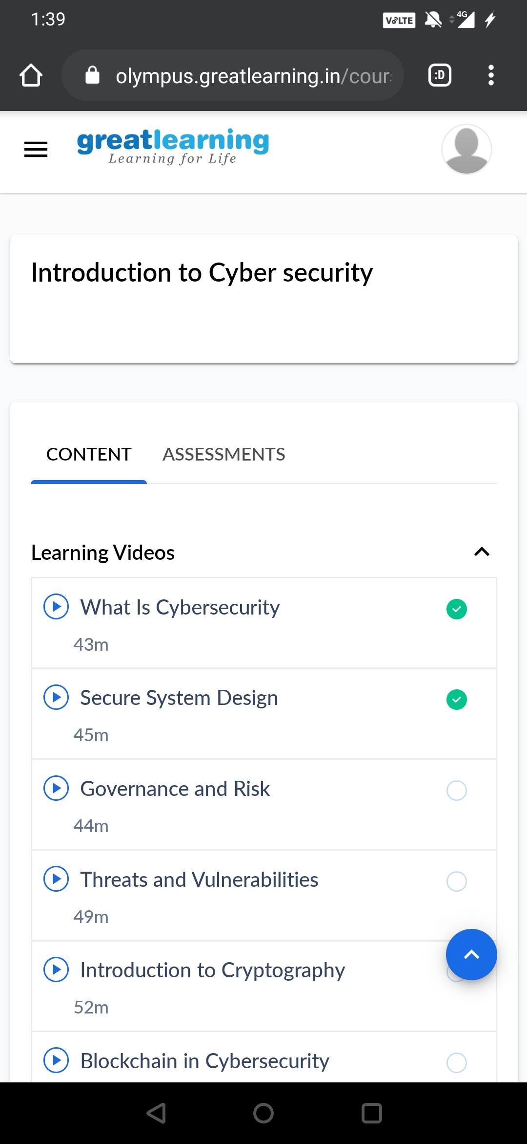

# CODE:

Program no:1

# Python code to demonstrate clearing a list using *= 0 method.

# Initializing lists

list1 = [1, 2, 3]

# Printing list1 before deleting

print ("List1 before deleting is : " + str(list1))

# deleting list using *= 0

list1 *= 0

# Printing list1 after *= 0

print ("List1 after clearing using